Name:

CODEBOT MISSION 2 LOG - Lesson 1

Pre-Mission Warm-Up
What are some things you can connect to a computer or laptop?
Why do you think you should learn how to program a computer?
Mission 2 Lesson 1 – Introducing CodeBot
Mission 2 Introduction
What is a “CodeBot”?
Several output and input peripherals are listed. Write the peripherals in the correct column:  - Accelerometer  - Buttons  - LED lights  - Line sensors  - Motors  - Proximity sensors  - Speaker  - Wheel rotation sensor (encoder)
  Outputs | Inputs
Mission 2 Objective 1
- Click on “motors” to add it to your toolbox.
- Use the Hint if you have trouble completing the goal.
Mission 2 Objective 2
What is an LED?
Complete the goal by clicking on any LED. There are 17 LEDs on the CodeBot, but they aren’t all easy to see. How many can you find?
Mission 2 Objective 3
- Click on “speaker” to add it to your toolbox.
Mission 2 Objective 4
- Click on “encoders” to add it to your toolbox.
- Complete the goal by clicking on an encoder. They are easiest to see from the back of the ‘bot.
Mission 2 Objective 5
- Click on “CodeBot Button” to add it to your toolbox.
There are three buttons on the ‘bot. What is the name of each button?
Mission 2 Quiz: Don’t Zap Your Bot!
What is static electricity?
What are three things you can do to protect CodeBot?
Mission 2: More CodeBot peripherals
- Click back on Objective 5. Close the Objective Panel so you can clearly see the CodeBot in the simulator.
Where are the line sensors on CodeBot?
Where are the proximity sensors?
Where is the accelerometer?
Where is the USB connector?
Where is the power switch?

CodeBot Review Label the parts of CodeBot.
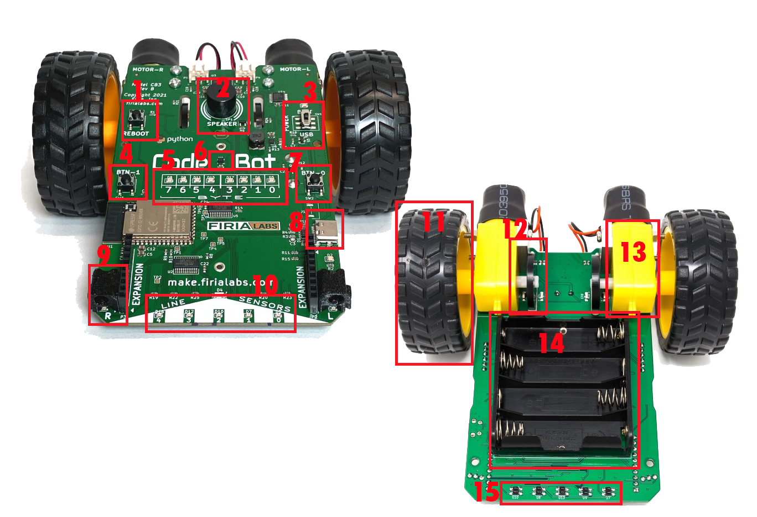
1. | 6. | 11.
2. | 7. | 12.
3. | 8. | 13.
4. | 9. | 14.
5. | 10. | 15.

CodeBot Parts:

- Accelerometer
- Battery pack
- User LEDs
- Wheel encoders
- Line sensor LEDs
- Line sensors
- Button 0
- Button 1
- Wheels
- USB connector
- Proximity sensors
- Reboot button
- Speaker
- Motors
- Power switch

Post-Mission Reflection
Inspect your CodeBot. All electronic devices you use have similar circuit boards inside. Name a few devices you use every day that might contain computer chips or “microcontrollers” such as the one on the ‘bot.
What is something you do that uses an electronic device? How do you think this activity was done before electronic devices?

